Computer Science…
what is it?

The ability to calculate at lightning speed with the aid of computers has transformed many aspects of our lives, from communication to science to medicine. When people began structuring complicated tasks into a form computers could understand, they realized that they needed a special brand of problem solving. They needed to find the best way to represent the problem, break tasks down into small pieces, and think logically about the steps it would take to solve it. This is Computer Science. With this background, you’ll have the skills necessary to solve today’s problems, from economics to the environment, social justice to medicine.
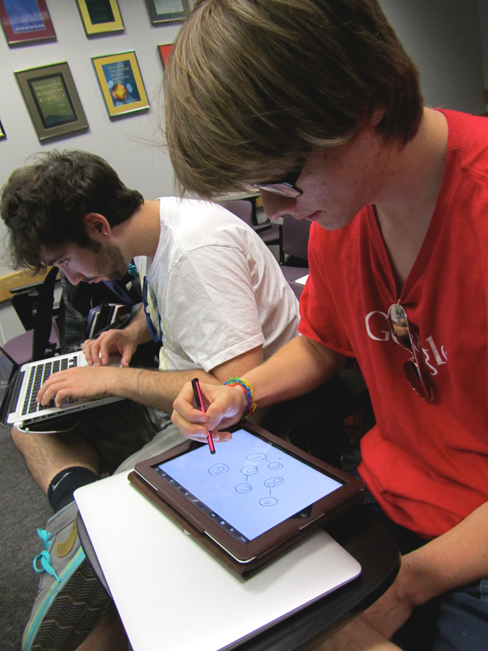
Some things you can do with Computer Science
For the practical-minded:
“Average starting salary: $63,402.”
-cnbc.com, 2011
“…the biggest increase in pay out of all the disciplines... up 4.1% from 2010.”
-money.cnn.com, 2012
“We've calculated that there are about two to three open jobs for every computer science grad this year.”
-dice.com, 2011
Solving a graph theory puzzle during an ACM meeting

Data Mining – Discover patterns and make predictions from complicated data.
Security – Protect important information, or test the strength of secure systems by trying to break them.
Software Engineering – Design desktop, web, or mobile applications, such as photo editors or games.
Scientific Computing – Advance sciences such as chemistry, physics, and biology by analyzing data and creating models and simulations.
Networking – Connect computers together to create a more integrated system and solve larger problems.
Artificial Intelligence – Create systems that respond intelligently to their environments or act like humans, and even problem solve on their own.
Computer Science at UA
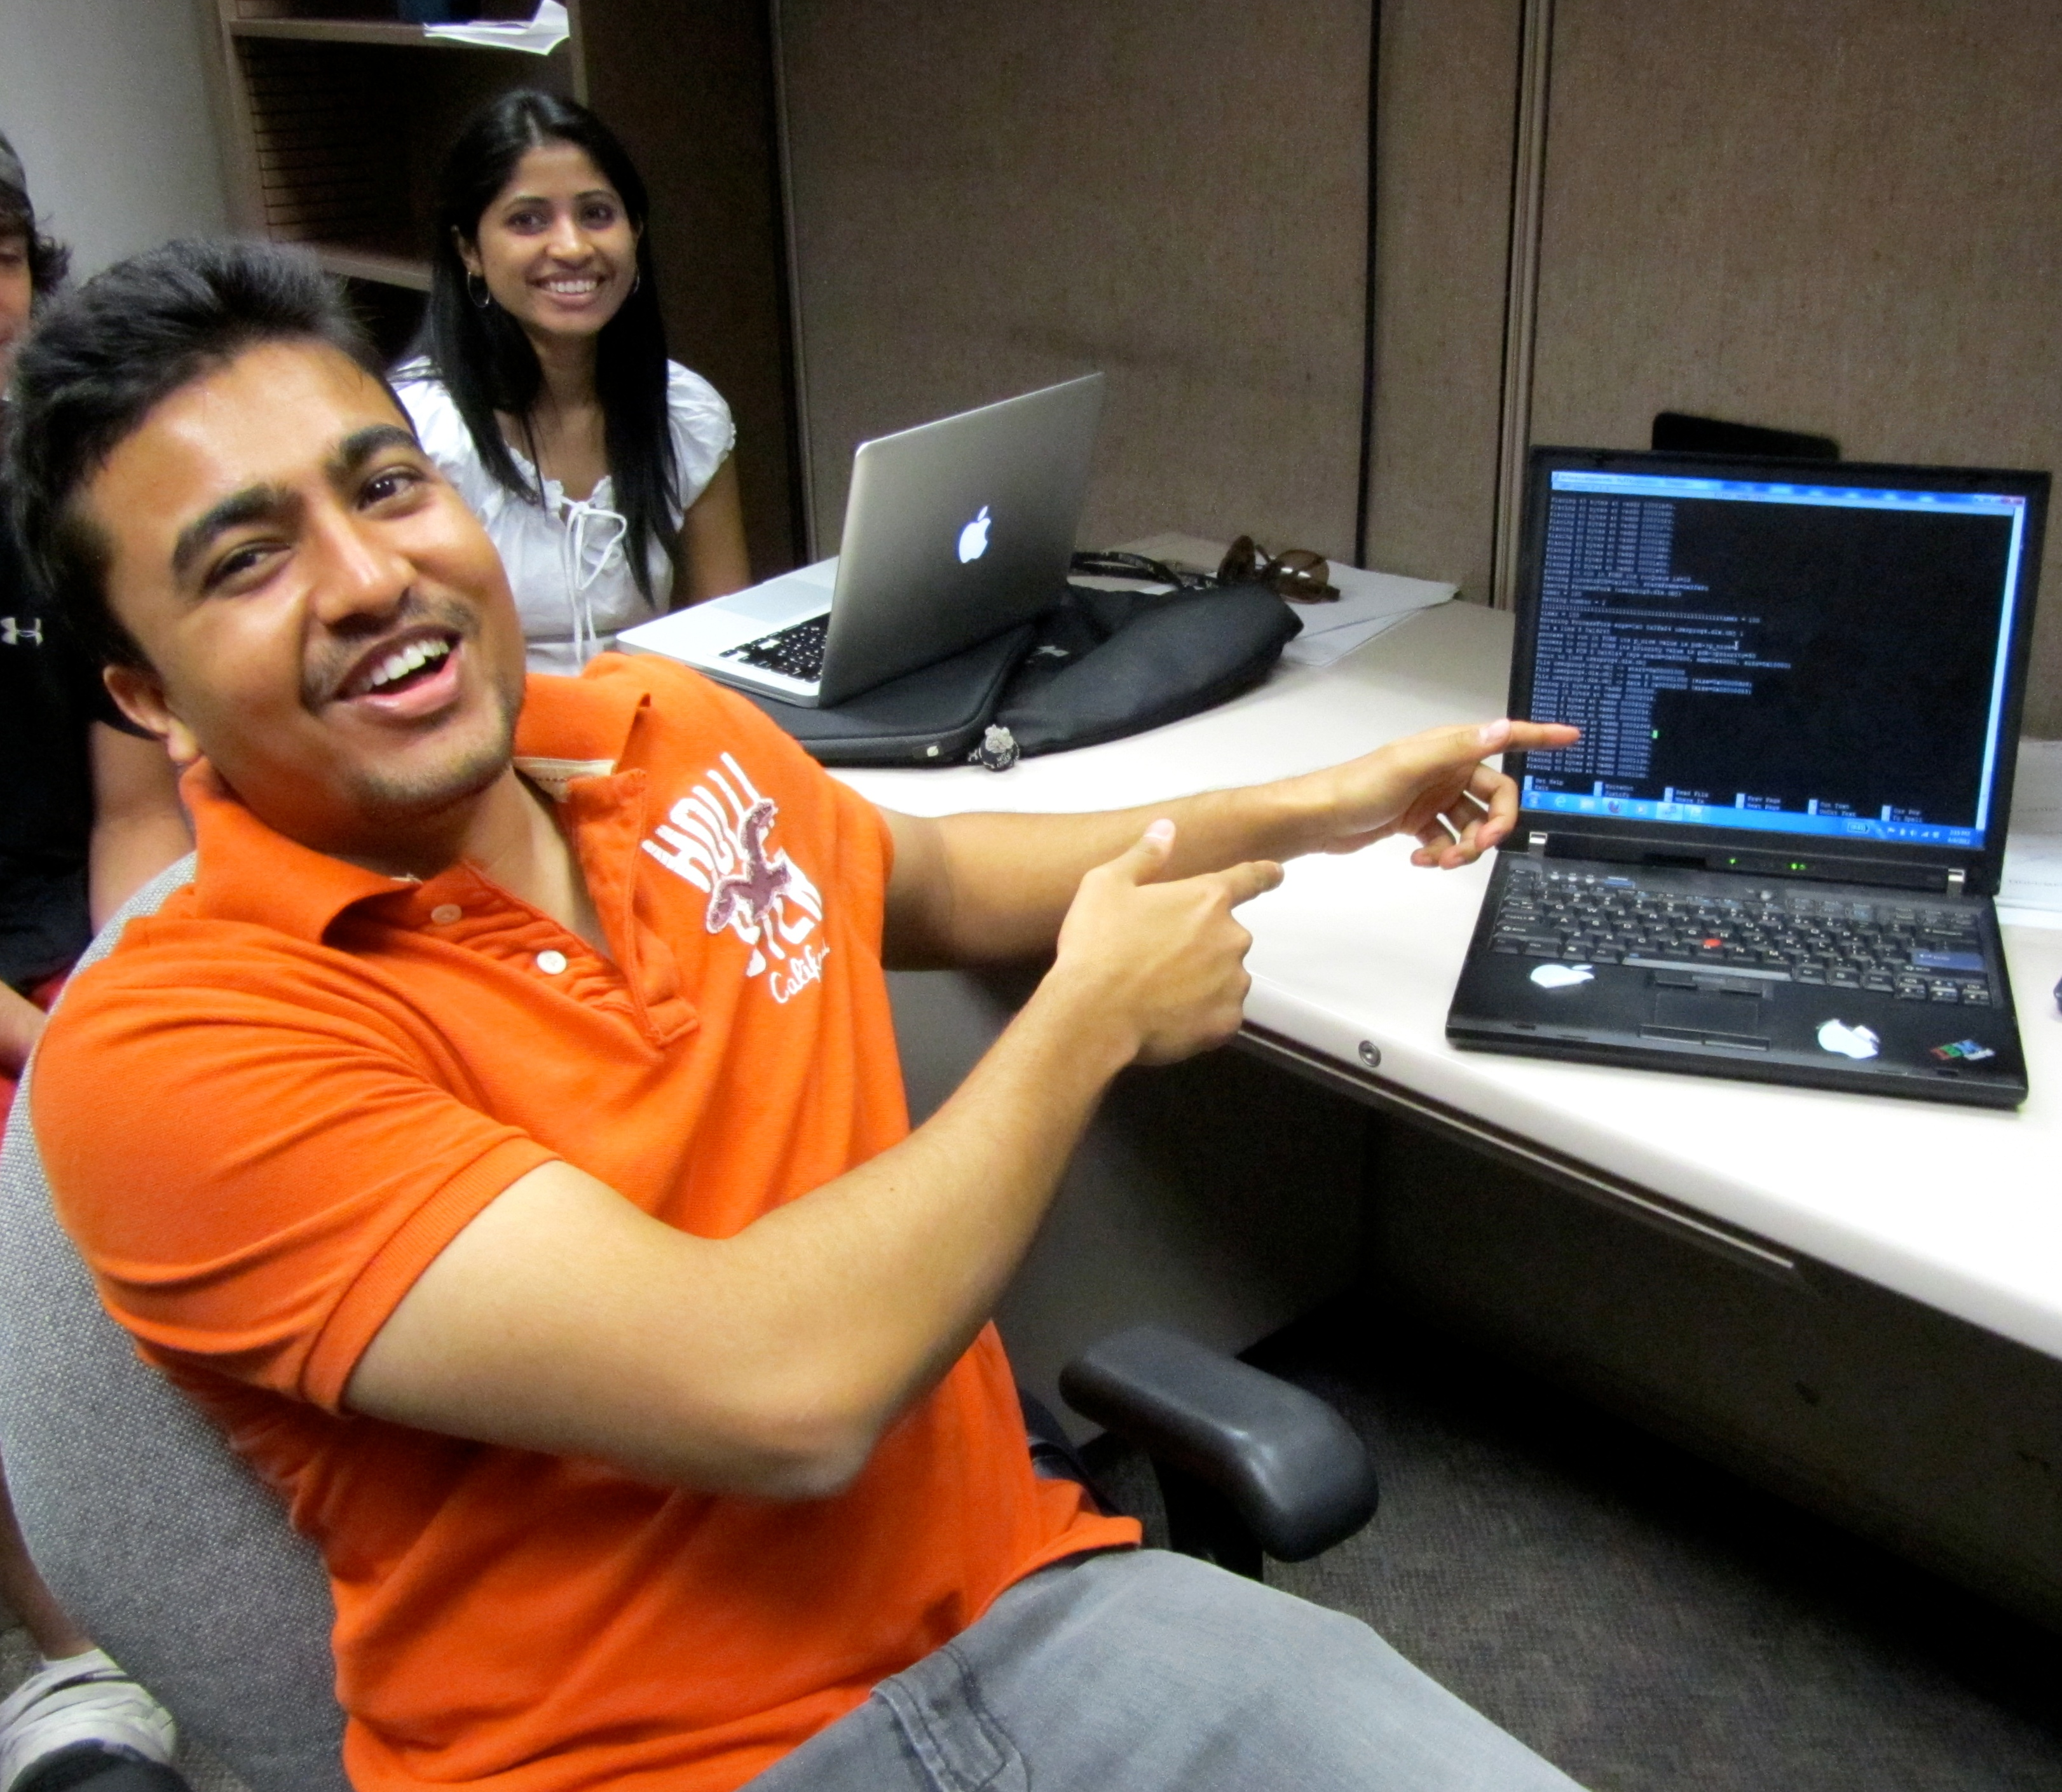
Showing off a project

Our department maintains a commitment to quality instruction. In the innovative Section Leader program, high-achieving students teach extra sections outside of lecture time, ensuring that all students get the attention they need to succeed.

As a Research I university, hands-on research with professors is encouraged. Students can also get involved through clubs like:
- ACM, UA Chapter (uofa.acm.org)
- Game Development Club (sites.google.com/a/email.arizona.edu/
ua-video-game-developers-club)
- Women in Computer Science (cs.arizona.edu/wics)

UA Computer Science graduates regularly find jobs at top tech companies as well as admission to graduate school.
Our students
“I didn't even consider it as a career path and I just happened to take a programming course. I loved it so much that now I am a CS major.”
“I think the fundamental joy behind CS is that it's all about learning how to build things.... it's even more rewarding when your creations end up helping people in some way.”
Livio De La Cruz
Ami Buczek

“I really like the Microsoft Big App On Campus contests and other competitions. I think I've won three phones, two video games and an Xbox 360. Plus shirts.”
“Do you recall ever saying to yourself When am I ever going to use this? while taking a class? This train of thought is extremely short in computer science.”
Want more info?
Rohit Umashankar
askus@cs.arizona.edu
520-621-4632
Gould-Simpson Building, room 901
1040 East 4th Street, Tucson AZ
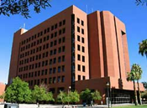
We are here

Check out these
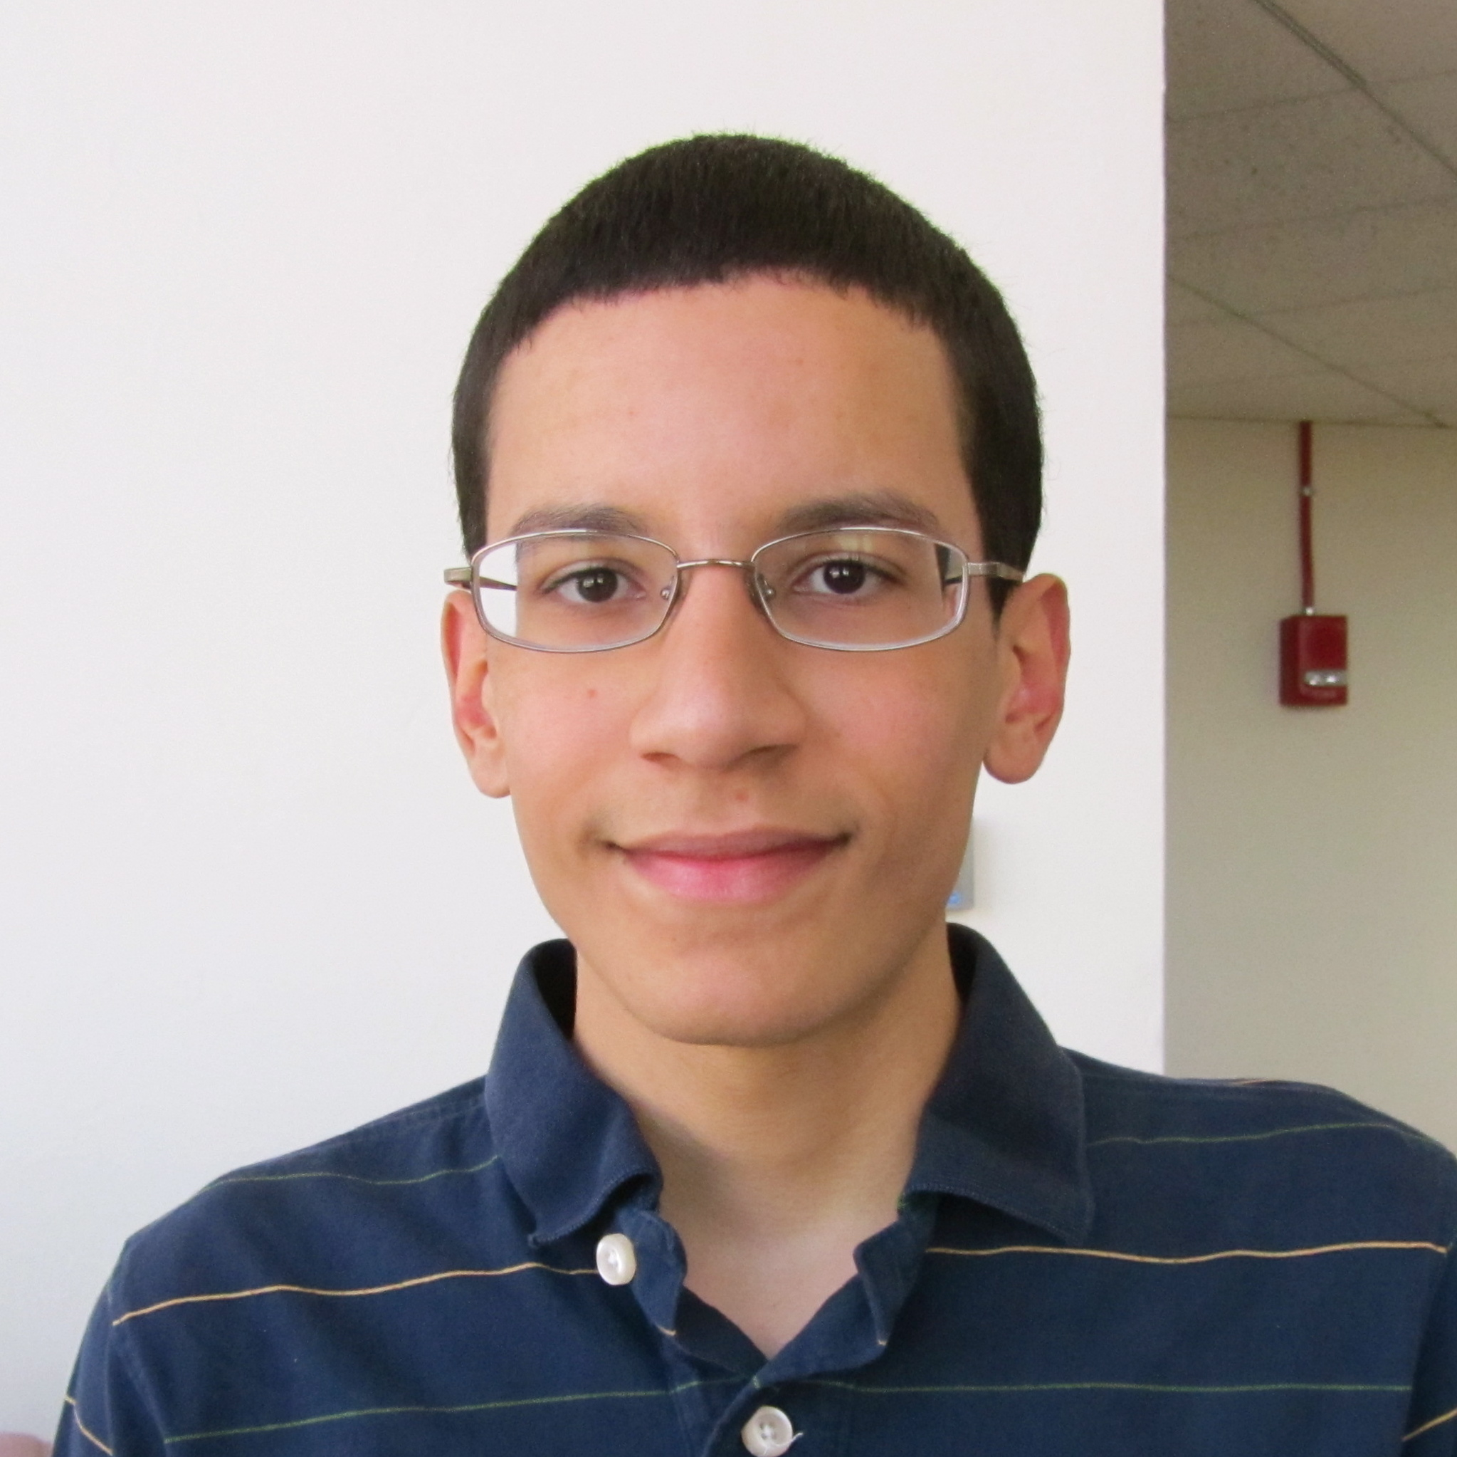
CS-related games and resources online

General:
An online magazine full of fun, bite-sized computer science topics.
cs4fn.org
Apply computing to your passions, from astronomy to film.
dotdiva.org
Learn to code:
Write small games and discover you’ve learned to program along the way.
James Magahern
inventwithpython.com
Think like a computer scientist while learning the language Python.
thinkcspy.appspot.com
